The New America (After the American Revolution)

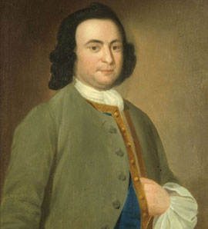
Match the painting to the person.
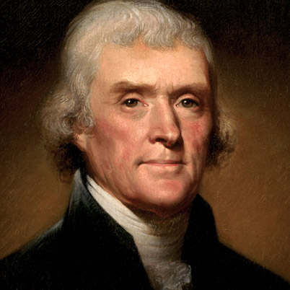

- George Washington
________

- James Madison (A) (B)
________
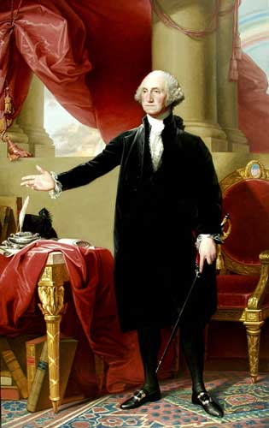
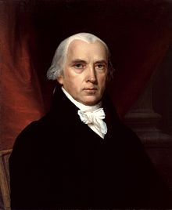
- George Mason
________

- Thomas Jefferson
________

(C) (D)
Draw or write two ideas from the Constitution.
- ________________________
________________________
________________________
________________________
________________________
________________________
________________________
________________________
________________________

- ___________________________
___________________________
___________________________
___________________________
___________________________
___________________________
___________________________
___________________________
___________________________

Identify the person to their accomplishment, or the document to what it states.

- George Mason A) wrote Virginia Statue of Religious Freedom

- George Washington B) wrote Virginia Declaration of Rights and did not sign the United State Constitution

- James Madison C) Was adopted on July 4, 1776 by the Second Continental Congress

- Thomas Jefferson D) Separated church and state

- Virginia Declaration of Rights E) Established religious freedom

- Virginia Statute of Religious Freedom F) Was known as the “Father of the Constitution”

- The Constitution G) Was known as the “Father of the Country”

- The Declaration of Independence. H) Was adopted on September 17, 1787 at a convention in Philadelphia, Pennsylvania.

- Label the timeline with the events in the correct order they occurred.
- George Washington becomes the first president.
- George Mason wrote the Virginia Declaration of Rights.
- The Constitution is signed and ratified.
- Thomas Jefferson wrote the Virginia Statute of Religious Freedom.
- The end of the American Revolution.

1776 1778 1780 1782 1784 1786 1788

Bonus: Make a word problem using the information in the timeline.

