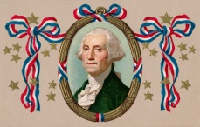
Name __________________________________________________ Date___________________
George Washington
Character Trait | At what age did he do this?  Child? Young man? Grown Man? | What did George Washington do or say that showed he was a good leader?
Smart
Honest

Brave/fearless

Fair

Willing to new ideas and listen to others

Has goals, thinks what he/she wants to do

